Develop Cloud Code Functions for Face Recognition Service APIs

*Code path for cloud code functions:*

Gitlab path : http://rnd-gitlab-ca-g.huawei.com/PaaS/servicestage/services/facerecodemo/tree/master/cloud-code

Step 1: Define a cloud code function for face recongnization APIs

If mbaas server is running behind proxy then proxy need to add in the request.

Ex:

reqToken({

url: 'https://iam.cn-north-1.myhuaweicloud.com/v3/auth/tokens',

method: "POST",

"rejectUnauthorized": false,

headers: {'Content-Type' : 'application/json'},

json: true,

body: tokenBody,

**proxy : 'http://<username>:<password>@proxyhost:port**

}, function (error, response, body) {

-------

}

**Create a Face Library**

faceLibrary.js

//face Library creation API implementation

Parse.Cloud.define('faceLibrary', function(req, res) {

//Get the valid token from the huawei public cloud

var reqToken = require('request');

var token;

var tokenBody = {

"auth": {

"identity": {

"password": {

"user": {

"name": "xxxx",

"password": "xxxx",

"domain": {

"name": "xxxx"

}

}

},

"methods": [

"password"

]

},

"scope": {

"project": {

"name": "cn-north-1"

}

}

}

};

var reqFaceLibr = require('request');

var bodyFaceLibr = {

"face_set_name": "apptest",

"face_set_capacity": 100000,

"external_fields" : {

"timestamp" : {

"type" : "long"

},

"id" : {

"type" : "string"

},

"number" : {

"type" : "integer"

}

}

};

reqToken({

url: 'https://iam.cn-north-1.myhuaweicloud.com/v3/auth/tokens',

method: "POST",

"rejectUnauthorized": false,

headers: {'Content-Type' : 'application/json'},

json: true,

body: tokenBody

}, function (error, response, body){

if (error) {

res.error(error);

}

else {

token = response.headers['x-subject-token'];

//call the face library

reqFaceLibr({

url: 'https://face.cn-north-1.myhuaweicloud.com/v1/017a290a8242480e82de8db804c1718d/face-sets',

method: "POST",

"rejectUnauthorized": false,

headers: {'Content-Type' : 'application/json', 'X-Auth-Token': token},

json: true,

body: bodyFaceLibr

}, function (error, response, body){

if(error) {

res.error(error);

}

else {

res.success(body);

}

});

}

});

});

**Upload face to Library**

faceUpload.js

//faceupload API implementation.

Parse.Cloud.define('faceUpload', function(req, res) {

//Get the valid token from the IAM service.

var reqToken = require('request');

var token;

var tokenBody = {

"auth": {

"identity": {

"password": {

"user": {

"name": "xxxx",

"password": "xxxx",

"domain": {

"name": "xxxx"

}

}

},

"methods": [

"password"

]

},

"scope": {

"project": {

"name": "cn-north-1"

}

}

}

};

var reqFaceUpload = require('request');

var bodyFaceUpload = {

"image_base64": req.params.path,

//"image_url":"https://ais-sample-data.obs.cn-north-1.myhuaweicloud.com/celebrity-recognition.jpg",

"external_image_id": "imageID1",

"external_fields": {

"timestamp": 12,

"id": "home"

}

};

reqToken({

url: 'https://iam.cn-north-1.myhuaweicloud.com/v3/auth/tokens',

method: "POST",

"rejectUnauthorized": false,

headers: {'Content-Type' : 'application/json'},

json: true,

body: tokenBody

}, function (error, response, body){

if (error) {

res.error(error);

}

else {

token = response.headers['x-subject-token'];

reqFaceUpload({

url: 'https://face.cn-north-1.myhuaweicloud.com/v1/017a290a8242480e82de8db804c1718d/face-sets/maheshtest2/faces',

method: "POST",

"rejectUnauthorized": false,

headers: {'Content-Type' : 'application/json', 'X-Auth-Token': token},

json: true,

body: bodyFaceUpload

}, function (error, response, body){

if (error) {

res.error(error);

}

else {

res.success(body);

}

});

}

});

});

**Retrieve the face from Library**

faceRetrieve.js

//face retrieve API implementation

Parse.Cloud.define('faceRetrieve', function(req, res) {

//Get the valid token from the IAM service

var reqToken = require('request');

var token;

var tokenBody = {

"auth": {

"identity": {

"password": {

"user": {

"name": "xxxx",

"password": "xxxx",

"domain": {

"name": "xxxx"

}

}

},

"methods": [

"password"

]

},

"scope": {

"project": {

"name": "cn-north-1"

}

}

}

};

//call the face retrieve api

var reqFaceRetrieve = require('request');

var bodyFaceRetrieve = {

"image_base64": req.params.path,

"sort" : [

{

"timestamp" : "asc"

}

],

"return_fields" : ["timestamp", "id"],

"filter" : "timestamp:12"

};

reqToken({

url: 'https://iam.cn-north-1.myhuaweicloud.com/v3/auth/tokens',

method: "POST",

"rejectUnauthorized": false,

headers: {'Content-Type' : 'application/json'},

json: true,

body: tokenBody

}, function (error, response, body){

if (error) {

res.error(error);

}

else

{

token = response.headers['x-subject-token'];

reqFaceRetrieve({

url: 'https://face.cn-north-1.myhuaweicloud.com/v1/017a290a8242480e82de8db804c1718d/face-sets/apptest/search',

method: "POST",

"rejectUnauthorized": false,

headers: {'Content-Type' : 'application/json', 'X-Auth-Token': token},

json: true,

body: bodyFaceRetrieve

}, function (error, response, body){

if (error) {

res.error(error);

}

else {

res.success(body);

}

});

}

});

});

Step 2: Open the MBaaS console and import the cloud code functions created in step 1

Go to ‘Enterprise’ and click ‘Functions’ and then ‘Add Function’.

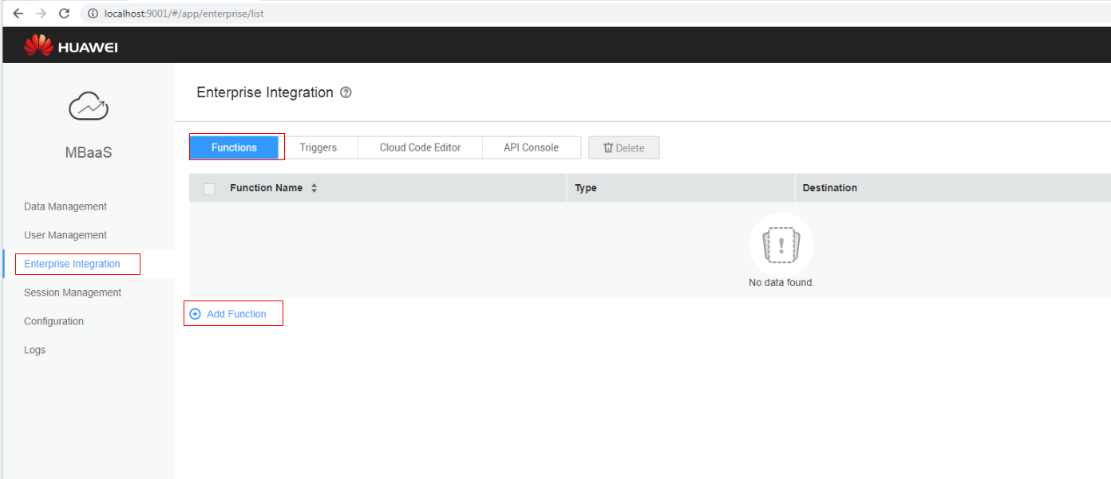

2) Select js files one by one and import.

Note: main.js will be there by default in mbaas-server.

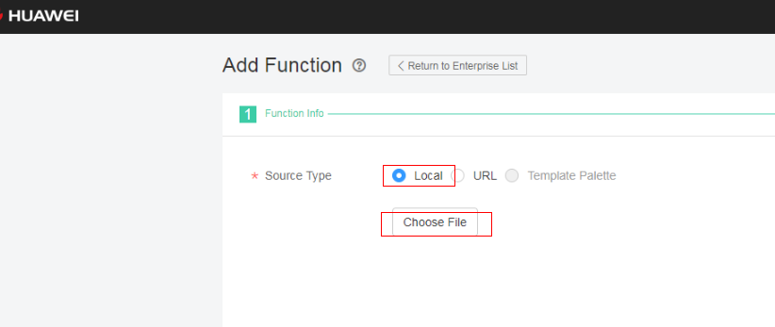

3) if we want to update the file we can update it on mbaas console.

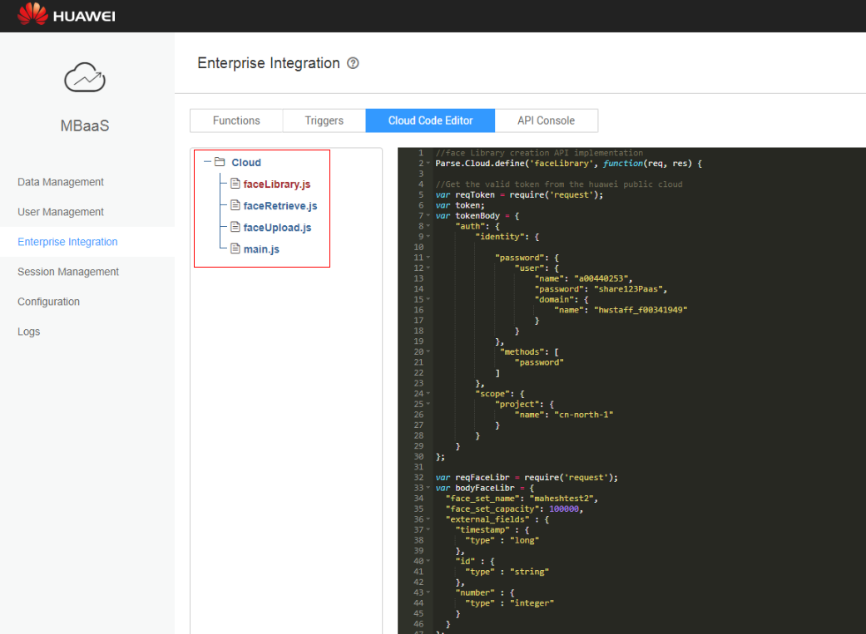

Step 3: Call the cloud code function from app

Example: Postman call

